**Mason Shepherd**

2190(←), 03C0(π), 03C1(ρ), 03C3(σ), 2260(≠), 00f7(÷),

2265(≥), 2264(≤), 2A1D(⨝), 1d4d8(𝓘)

**Homework 3: due February 5th 11:59PM.**

**[16 points] 8.16.**  Specify the following queries on the COMPANY relational database schema shown in Figure 5.5 using the relational operators discussed in this chapter. Also show the result of each query as it would apply to the database state in Figure 5.6.

* 1. Retrieve the names of all employees in department 5 who work more than 10 hours per week on the ProductX project.

Ans:

PRODUCTX_NUM ← π<Pnumber>(σ<Pname = ‘ProductX’>PROJECT)

ESSN_X_10(Essm) ← π<Essn>(σ<Hours ≥ 10.0>(WORKS_ON ÷ PRODUCTX_NUM))

SSN_X_10 ← ρ(Ssn)ESSN_X_10

RESULT ← (π<Fname, Minit, Lname, Ssn>EMPLOYEE) ÷ SSN_X_10

R1 ←

* 1. List the names of all employees who have a dependent with the same first name as themselves.

Ans:

EMPLOYEE1 ← π<Fname, Minit, Lname, Ssn>EMPLOYEE

DEPENDENT1 ← π<Essn, Dependent_name>DEPENDENT

EMP_AND_DEP ← EMPLOYEE1 * ρ(Ssn, Dependent_name)DEPENDENT1

RESULT ← π<Fname, Minit, Lname>(σ<Fname = Dependent_name,>EMP_AND_DEP)

* 1. Find the names of all employees who are directly supervised by ‘Franklin Wong’.

Ans:

FW_SSN ← ρ(Super_ssn)(π<Ssn>­(σ<Fname = ‘Franklin’ AND Lname = ‘Wong’>EMPLOYEE))

RESULT ← π<Fname, Minit, Lname>(EMPLOYEE ÷ FW_SSN)

* 1. For each project, list the project name and the total hours per week (by all employees) spent on that project.

Ans:

PROJECT_HOURS ← ρ(Pnumber, Total_hours)(Pno𝓘SUM Hours(WORKS_ON))

RESULT ← π<Pname, Total_hours>(PROJECT * PROJECT_HOURS)

* 1. Retrieve the names of all employees who work on every project.

Ans:

WORKS_ON1 ← ρ(Esn, Pnumber)(π­<Essn, Pno>WORKS_ON)

ALL_PNUM ← π<Pnumber>PROJECT

ALL_PROJ_ESSN ← WORKS_ON1 ÷ ALL_PNUM

RESULT ← π<Fname, Minit, Lname>(σ<Ssn = Essn>(EMPLOYEE × ALL_PROJ_ESSN))

* 1. Retrieve the names of all employees who do not work on any project.

Ans:

EMP_WORKS ← π<Fname, Minit, Lname, Ssn>(EMPLOYEE * ρ(Ssn, Pno, Hours)WORKS_ON)

RESULT ← EMPLOYEE – EMP_WORKS

* 1. For each department, retrieve the department name and the average salary of all employees working in that department.

Ans:

DNO_AVG_SAL ← ρ(Dnum, Avg_Sal)(Dno 𝓘 AVERAGE Salary(EMPLOYEE))

RESULT ← π<Pname, Avg_Sal>(PROJECT * DNO_AVG_SAL)

* 1. Retrieve the average salary of all female employees.

Ans:

FEM_EMP ← σ<Sex = ‘F’>EMPLOYEE

RESULT ← π<Average_salary>(Sex 𝓘 AVERAGE Salary(FEM_EMP))

**[6 points] 8.22.** Consider the two tables *T*1 and *T*2 shown in Figure 8.15. Show the results of the following operations:

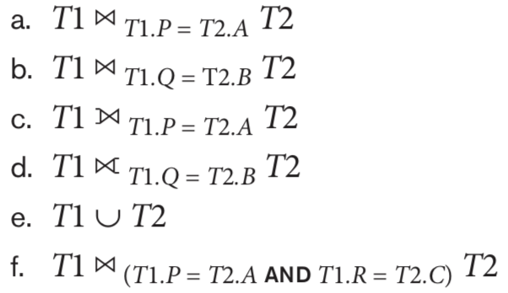

Ans(s):

a)

**T3**

**P Q R A B C**

10 a 5 10 b 6

10 a 5 10 b 5

25 a 6 25 c 3

b)

**T3**

**P Q R A B C**

15 b 8 10 b 6

15 b 8 10 b 5

c)

**T3**

**P Q R A B C**

10 a 5 10 b 6

10 a 5 10 b 5

15 b 8 ----null----

25 a 6 25 c 3

d)

**T3**

**P Q R A B C**

----null---- 25 c 3

15 b 8 10 b 6

15 b 8 10 b 5

e)

**T3**

**P Q R**

10 a 5

15 b 8

25 a 6

10 b 6

25 c 3

10 b 5

f)

**T3**

**P Q R A B C**

10 a 5 10 b 5